- MOTHERBOARD AND CPU (CENTRAL PROCESSING UNIT)

Q1. Draw a labeled diagram of an ATX motherboard and mark at least 8 different slots and ports (such as RAM slots, PCIe slots, SATA ports, USB headers, CPU socket, power connector, etc.).
Ans.
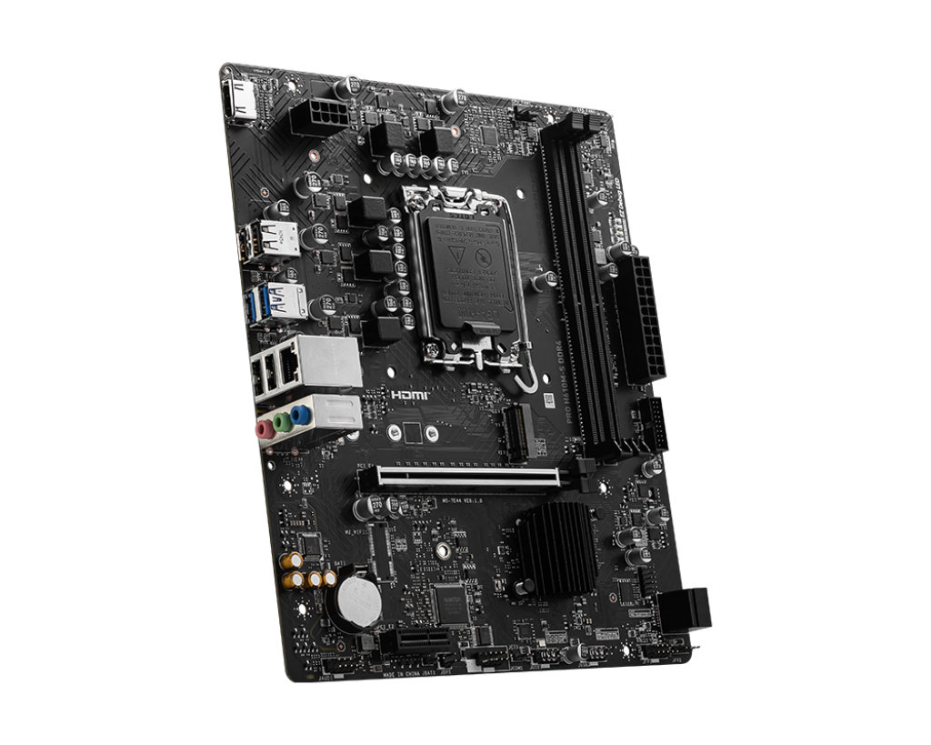
RJ45 port and USB ports
8 PINS CPU POWER CONNECTOR
24 PINS ATX POWER CONNECTOR
DISPLAY PORT FOR MONITORS
CPU SOCKET
RAM SLOTS
PCIe (PCI Express) x16 SLOT
AUDIO JACKS FOR CONNECTING SPEAKERS AND MICROPHONE
NVME SSD SLOT

Q2. Research and list 3 popular CPU socket types (for example: LGA1151, AM4, LGA1200) and name one compatible CPU model for each.
Ans. There are many different types to CPU socket is available with different types of CPUs.
I have listed different types of CPU sockets with their compatible CPUs

- Socket AM5 (LGA 1718) is Compatible with AMD Ryzen 9 9950x3d CPU
- Socket sTR5 is Compatible with AMD THREADRIPPER Pro 9995wx CPU (USED FOR SERVERS AND WORKSTATIONS)
- Socket LGA 1700 is compatible with Intel i5-14600k (14th Generation)
- Socket PGA478 is compatible with Intel Pentium 4 (3.0 GHz)
- Socket BGA1449 is compatible with Intel Core i7-1165G7 (11th Generation)
- Types of Sockets
- LGA – LGA stands for (Land Grid Array) A CPU socket where the pins are on the motherboard and the CPU has flat contacts
- PGA – PGA stands for (Pin Grid Array) A CPU socket design where the pins are on the CPU and the holes are on the motherboard socket. It was commonly used in older AMD processors.
- BGA – BGA stands for (Ball Grid Array) A CPU package where the processor is soldered directly to the motherboard using tiny solder balls, so it cannot be easily removed or upgraded. It is Usually found in Laptops
NOTE – AM5 Socket is same as LGA Socket and AM4 Socket is same as PGA Socket.

Q3. Explain in your own words the primary functions of the CPU and the chipset on a motherboard, and describe how they work together when you open a music app like Spotify.
Ans. Firstly we try to understand what is the work of CPU and Chipset on Motherboard.
- Work of CPU
- The CPU is the main processor of the computer. It performs calculations, processes instructions, and controls all the tasks needed to run programs. It acts as the "brain" of the computer.

- Work of Chipset
- The chipset is a group of electronic components on the motherboard that manages communication between the CPU and other hardware, such as RAM, storage drives, USB ports, and other devices. It helps all the components work together smoothly

- How They Work Together When You Open Spotify
- When you open Spotify, the CPU processes the instructions needed to start the app, display the interface, and play music. At the same time, the chipset helps transfer data between the CPU, RAM, storage, audio hardware, and internet connection. Together, they ensure Spotify opens quickly, loads your songs, and plays music without interruptions.

Q4. Find a clear photo of a real motherboard (from the internet or your own device), and identify at least 5 different ports or slots by circling them and labelling each one.
Ans.
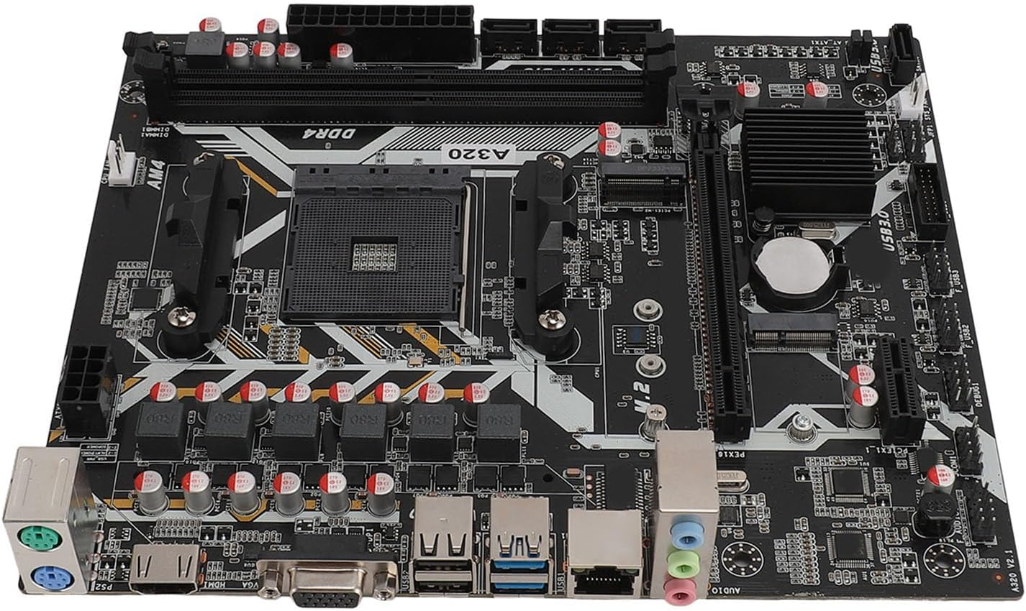
NVME M.2 SSD SLOT
USB 2.0 AND 3.0 Slots
VGA PORT
SATA SSD OR HDD SLOTS
PCIe (PCI Express) x16 SLOT

RAM SLOTS
PS2 Ports

